

|  |
| --- |
| Raspberry pi remote control vehicles via Wi-Fi |

**Project Report**

|  |
| --- |
| Student number: 793903  Beng(Hons)Electrical Engineering  Supervisor's Name: Dr Shikun Zhou  Moderator's Name: Dr Chi Nguyen |

School of Engineering

Faculty of Technology

May 2017

**Abstract**

The aim for this project is use raspberry pi replace the original control unit inside the toy tank and finally achieve use laptop or smart phone remote control the tank with multifunctional. The design process can divide into hardware and software part. In software part Python language used to built webserver and also GPIO settings; HTML is programming the controller website interface which need JavaScript, JQurey and Css support. The hardware design used motor driver to simplify electronic circuit. Raspberry pi have used as an local area network host which built an access point make the connected devices can access the controller website. The overall ideal of design is user’s device through raspberry pi built-in AP access controller website click button transmit URL to webserver to control GPIO output.

Keyword: raspberry pi, python, toy tank, HTML, webserver, AP.

**Course summary**

Topic: Raspberry pi remote control vehicles via Wi-Fi

Location: University of Portsmouth, Engineering Department

Dates: 04 October 2016 – 04 May 2017

1. Introduction

**1.1 University of Portsmouth**

“The University of Portsmouth was founded in 1908 as the park building opened as a Municipal college and public library. The focus was on chemistry and engineering. The roots of the University can be traced back even further to the Portsmouth and Gosport School of Science and the Arts. In 1960 the college was renamed Portsmouth Polytechnic. In 1992, Portsmouth Polytechnic was granted university status, becoming the University of Portsmouth on 7 July.” ( )

Today, she is 43rd best university in the UK, have 23000 student and 2500 full-time equivalent staff.

**1.2 Introduction to the course**

This project takes place in the final year that should finish independently. In general, this is first experience for must of us to finish one prototype with vary knowledge. This course was leader by Dr. Shukun Zhou from 1st November 2016 to 5th May 2017, at University of Portsmouth, England, in the Electronic Engineering course, Engineering Department. Dr. Zhou the tutor of this project, lead the way and enthusiastic to offer help for every student. This project is aimed at to encourage future student to be more brave and going toward focus on new technology. This is why this project has so much fun and challenge.

**1.3 Introduce to the project**

**1.3.1 Project Aim**

This project it is based on a raspberry pi and a remote controlled toy vehicle. Use raspberry pi to replace the toy vehicle’s original controlled system and receiver system, use smartphone or computer replace the remote controller via Wi-Fi.A web server in PI will be provided to interfacing the remote toy vehicle with any device such as a laptop, a smart phone or a tablet.

**1.3.2 Commercial used**

**1.3.2.1 Education**

Raspberry pi as a start kit for most programming beginners have already widely used in variety territory. Obviously raspberry pi is a perfect teaching tool to young students. Cause it have friendly interface and visible application. With more funny and interesting example will remarkable inspire young student’s interest. Show them the code is not just alphabet with sample organization it have the ability to do some job.

**1.3.2.2 Future Toy**

There are many toy companies but the majority of them just make dolls and sample model like a hundred years ago. With the technology step forward there do have many remote control toys but most of them just have sample functions. This project built a smart remote toy frame, with sample change of actions this frame can use in many kinds of toy, with video stream children can enjoy more fun. And this frame based on raspberry pi have ability do further development.

**1.3.2.3 Internet of things**

“The **Internet of things** (**IoT**) is the inter-networking of physical devices, vehicles (also referred to as "connected devices" and "smart devices"), buildings, and other items embedded with electronics, software, sensors, actuators, and network connectivity that enable these objects to collect and exchange data.”

(En.wikipedia.org, 2017)

This project built a local area network, devices connect to this network can communicate freely with each other. Thus this system can use as any basic IOT system, with more vehicles (robots) or devices (sensors) connect together it have the ability developed a system for manufactory or smart home system based on my project.

**1.4 Background and value**

**1.4.1 Background**

Now a day’s remote control robot or automatic drive vehicles become the mainstream of technologies development. Aim to change people’s life style and factory manufacture. Remote control vehicle (robot) can widely use in various way to complete many jobs that may danger to human. Actually, more and more remote control robot used in rescue mission and made a great contribution. And war robot is also no long a dream as some news said US military are testing some kind of remote control war machine aim to decrease the casualties. Therefore the prospect of remote control vehicle is unlimited. And there are some companies like Tesla, Google and Sony is leading the way for remote control and automatic technologies. The significance of remote control vehicle (robot) is this manufacture machines have the ability to do high-risk job with human control. The aim of remote control research is not going to build an android (AI), but it is the most efficiency way to combine people’s (workers) experience and robot enlargement the potential of human world.

**1.4.2 Applications**

Remote controller vehicle (robot) or Telerobotics widely used in space explore, Telepresence and videoconferencing, marine application and Medical robot.

“• Space use

With the exception of the Apollo program most space exploration has been conducted with telerobotic space probes. The International Space Station (ISS) uses a two-armed telemanipulator called Dextre. More recently, a humanoid robot Robonaut has been added to the space station for telerobotic experiments.

• Telepresence

The robot avatar can move or look around at the command of the remote person.”

• Marine application

Marine remotely operated vehicles (ROVs) are widely used to work in water too deep or too dangerous for divers.

•Medical use

Additionally, a lot of telerobotic research is being done in the field of medical devices, and minimally invasive surgical systems.” (En.wikipedia.org, 2017)

**1.5 Problem statement**

In this project the difficulty is how to make the motor action when button have been clicked. A webserver and an website interface have been used to solve the problem. Python webserver and html coding is primary job for this project.

**1.6 Extension**

Dr. Zhou suggests an extension, which add a camera on the tank. The video could be displayed in real time on the website. Thus, the toy tank could be controlled in video stream. A raspberry picam will add to my project to offer video stream and a laser unite also add for aiming target. Therefore users can shoot BB bullet right on the target without directly view.

**2. Overview**

**2.1 project objective**

The main Objective of this project is control the tank through laptop or smart phone. Use Raspberry pi python language programming achieves remote control by an URL. Then for user friendly control an html file will use as controller interface. Video stream and laser aim as extension work also add in this project.

**2.2 Technology Used**

**2.2.1 Raspberry pi**

**2.2.1.1 introduce to raspberry pi**

Raspberry Pi is designed for computer-programming education, it is a Linux system credit card size microcomputer, based on ARM-based microcomputer motherboard use SD / MicroSD card as the hard drive, with four USB ports and a 10/100 Ethernet interface, can be connected to the keyboard, mouse and network cable, also has a video analog signal TV output interface and HDMI high-definition video output interface, with all the basic functions of the PC only need connect to a screen and keyboard, then it can perform such as spreadsheet, word processing, play games, play high-definition video and many other features.

**2.2.1.2 Raspberry pi GPIO**

GPIO (General-purpose input/output) through raspberry pi GPIO settings can easily change this pin as an input or output, to read data from sensors or control various boards.

**2.2.1.3Raspberry pi built-in Wi-Fi**

Raspberry pi have built-in Wi-Fi module (wlan0), with sample adjust raspberry can became and wireless access point (AP) built a local area network. Users device should join in this network then built the website application.

**2.2.2 Python**

Python has become one of the most popular programming languages, which is a purely free software, source code and interpreter CPython follows the GPL (GNU General Public License) protocol. Python syntax is concise and clear, one of the characteristics is forced to use white space (white space) as a statement indent. Python has a rich and powerful library. It is often nicknamed glue language, can be made in other languages with a variety of modules (especially C / C + +) is easy to link together. Due to the simplicity, readability and extensibility of the Python language, the development environment of the Python language and its extensive library is very suitable for engineering and technology and even develop applications.

**2.2.3 webserver**

“A web server is a computer system that processes requests via HTTP, the basic network protocol used to distribute information on the World Wide Web. The term can refer to the entire system, or specifically to the software that accepts and supervises the HTTP requests.” (En.wikipedia.org, 2017)

**2.2.4 Access point**

Wireless Access Point (AP) like the HUB in traditional wired network, which is the most commonly used equipment to set up a small wireless LAN. AP is equivalent to a bridge connecting the wired network and the wireless network, the main role is to connect the various wireless network clients together, and then the wireless network access to Ethernet.

**2.2.5 LAMP**

“LAMP (Linux-Apache-MySQL-PHP) Web site architecture is the current international popular Web framework, which includes: Linux operating system, Apache web server, MySQL database, Perl, PHP or Python programming language, all components and open source software. LAMP has a cross-platform, high performance, low price advantage, so LAMP regardless of performance, quality or price are enterprises or individuals to build the site's preferred platform.” (En.wikipedia.org, 2017)

**2.2.6 HTTP**

HTTP (Hyper Text Transfer Protocol). In simple terms it is an application-level protocol that allows Hypertext Mark-up Language (HTML) documents to be sent from the Web server to the client's browser. Each time the HTTP operation has at least the following process: First, the client and the server to establish a connection; established after the establishment of the client in accordance with the protocol format to send the request; server received a request, the same response in a format to return the data; The client is disconnected from the server.

**2.2.7 HTML**

“Hypertext Markup Language, an application under the standard common markup language. “Hypertext" refers to the page can contain pictures, links, and even music, programs and other non-text elements. The structure of the hypertext markup language includes the "head" section, and the "main body" section, where the "head" section provides information about the web page, and the "subject" section provides the specific content of the web page.” (W3schools.com, 2017)

**2.2.8 JavaScript**

“JavaScript is a network of scripting language, has been widely used in Web application development, commonly used to add a variety of web pages for dynamic functions, to provide users with more smooth and beautiful browsing. JavaScript scripts are usually embedded in the HTML to achieve their own functions. Now JavaScript is the most popular scripting language on the Internet, and this language is available for HTML and web. It is a scripting language that can be embedded directly into an HTML page. With cross-platform features, support by majority of browser support can run in a variety of platforms.” (En.wikipedia.org, 2017)

**2.2.9 jQuery**

JQuery is a excellent JavaScript framework with fast and concise. The purpose of the jQuery design is "write Less, Do More". It encapsulates JavaScript's frequently used code, providing a simple JavaScript design pattern that optimizes HTML document manipulation, event handling, animation design, and Ajax interaction.

**2.2.9 CSS**

CSS (Cascading Style Sheets) is a computer language used to express HTML file styles. CSS can not only static modification of the page, but also with a variety of scripting language dynamically formats the elements of the page. CSS can be pixel-level layout of the page pixel-level precise control, support for almost all font style, with the page object and model style editing ability. CSS provides a rich set of document styles, as well as the ability to set text and background properties.

**3. Design**

**3.1 Overall design**

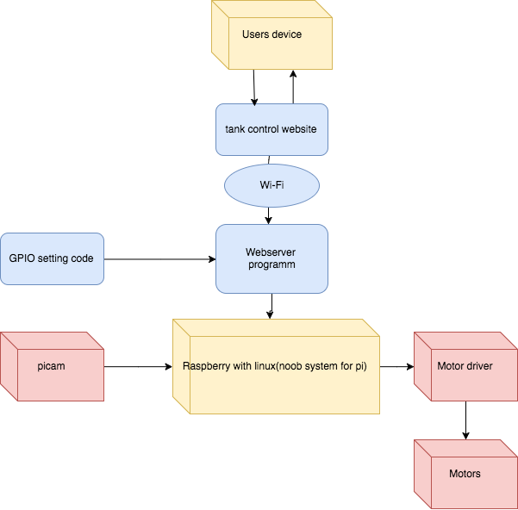

Figure 1

All the original control board in side the tank has replaced by raspberry pi only left five DC motors, which have, reconnect to motor drivers (L298N). Raspberry pi used as main control unit inside the tank, through pi GPIO to control motor driver. And python web server is running in locate area network (LAN) listening on the IP address when data in side URL received, web server will identify the action then drive GPIO python code then motor driver will drive motors. And the controller website interface is used to send the URL.

**3.2 software and hardware chosen**

**Software entitles**

• RASPBIAN: raspberry pi Linux operating system.

• Sublime Text: used for html coding.

• IDLE(2.7): python coding in computer.

• Create_ap: built access point use raspberry built-in Wi-Fi.

• Mjpg-stream: video stream.

• Xrdp: raspberry pi remote desktop in computer.

**Hardware entitles**

•RC tank: The henglong RC tank.

•Raspberry pi: Raspberry pi 3 B+ with built in Wi-Fi.

•L298N: motor driver.

•Picam: raspberry pi original camera.

•Battery: 5volt recharge power bank.

**Hardware analyze**

Picam is raspberry pi authority camera part us FPC (flexible printed circuit) connect to raspberry camera port. 5v power bank used as raspberry power source connect to raspberry pi micro-USB port. 5v out and GND pin in raspberry pi IO port have connect to motor drivers for logic power.

**3.3 Data flow**



Figure 2

• Between user’s device and raspberry pi

User’s device through Wi-Fi connect to raspberry pi local network access the controller html file send commands( data in url) to webserver listening address.

• Between Raspberry pi and Motor driver

A webserver process listening on the address and spilt url data out, driver gpio setting code driver motor driver.

• Between motor driver and DC motor

Motor driver connect to 7.2-volt power source control by GPIO.

**3.4 Main functions**

**3.4.1 GPIO setting**

Python GPIO setting code will drive by the webserver though change GPIO out control motor drivers, thus the tank is under control.

**3.4.2 webserver program**

As mentioned in aim a webserver will used to listen at my control website address and waiting for actions, once the URL have received.

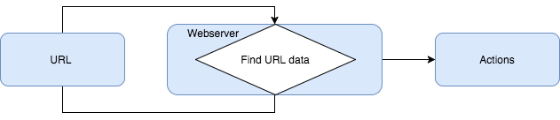

Figure 3

URL (Uniform Resource Locator) is send from device webserver job is listen at one IP address spilt URL (<http://ip:port/car>?a=X) X is the data that webserver looking for.

The output of the system is raspberry pi GPIO high/low, once the URL data received by webserver the data will spilt out and change GPIO value, then wait next data.

**3.4.3 Controller website**

To control the tank through laptop, iPad or smartphone, the most common and sample way is built a website, and use as tank remote controller. Because website don’t have operate system limit also easy than applications. And user must be able to control the movements of the tank. The original radio frequency remote controller also controls the turret and the electrical BB cannon. The developed website should cover all this actions. In summary, all the actions allowed by the original remote controller must allowed by the controller website.

The input of the system is the URL data transmit from controller website, So in controller website every button will link a unique URL data with JavaScript click function, once clicked the data will send out but the website should stay in that page, waiting for next click. Thus this website should send the data to server in background and update web page without reloading the page.

**4. Work**

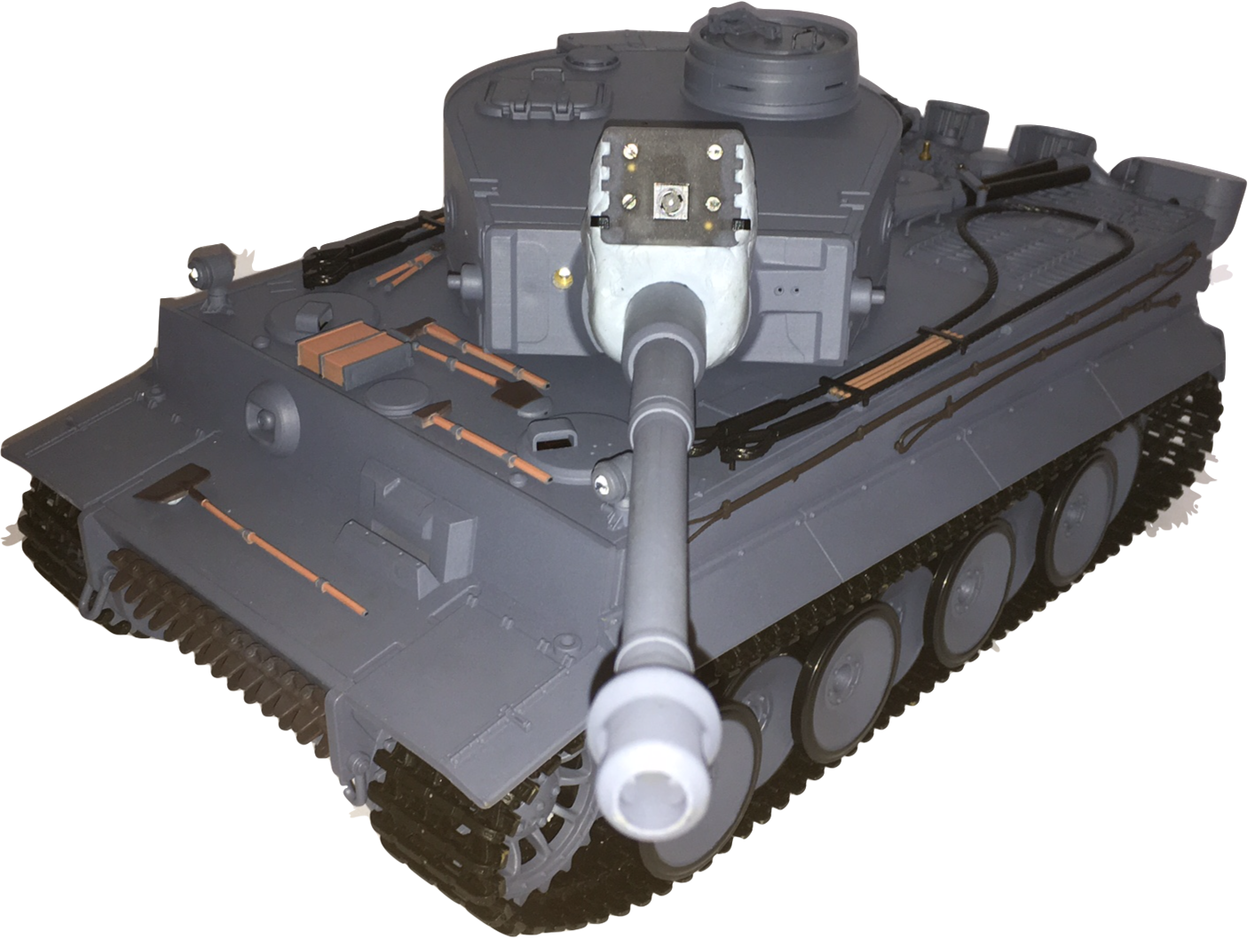

Figure 4

**4.1 The RC toy tank**

This high quality RC toy tank is bought from Amazon.co.uk, which offer enough space to place raspberry pi and also for motor drivers.

This toy is made by henglong as a 1:16 scale real radio control battle tank, German tiger I early production.

Which have 5 DC motor inside to control fifteen different motor pattern.

**4.2 The Electrical schematic of original RC tank**

Appendix Figure 1.

**4.3 Pi tank electrical schematic.**

Speaker, smoke unit, main control board has been removed for more space for batteries. Upper chassis board still used but headlight LED has removed. The original 7.2 Volt power connects to motor drivers but the switch have been retained. From electrical schematic there have five DC motor as mention before, to control this motors at least three motor drivers will require.

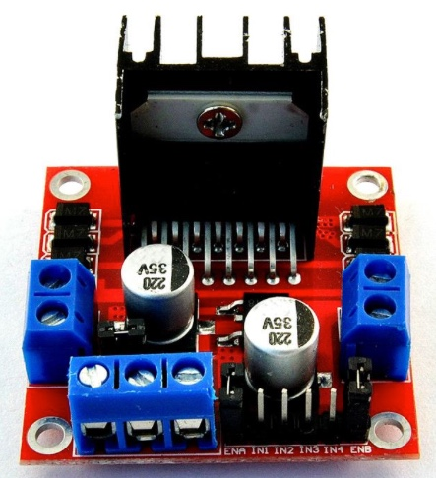

Figure 6

**4.4 Motor Driver L298N**

A motor driver is a little current amplifier; the function of motor drivers is to take a low-current control signal and then turn it into a higher-current signal that can drive a motor.

Motor B

Motor A

Motor drivers can be found in a wide array of applications including: Relay and solenoid switching, Stepping motor, LED and incandescent displays, Automotive applications and Car navigation systems.

L298N state table

|  |  |  |  |  |  |
| --- | --- | --- | --- | --- | --- |
| **DC motor** | | **IN1** | **IN2** | **IN3** | **IN4** |
|
| Motor A | Forward | HIGH | LOW | X | X |
| Backward | LOW | HIGH | X | X |
| Stop | LOW | LOW | X | X |
| Motor B | Forward | X | X | HIGH | LOW |
| Backward | X | X | LOW | HIGH |
| Stop | X | X | LOW | LOW |

**4.5 Power on board and wireless connect with computer**

**4.5.1 Raspberry pi set up**

Materials

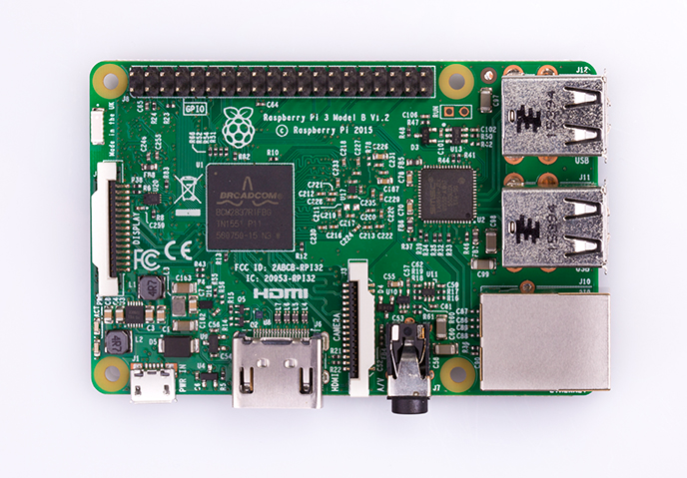

Figure 7 Raspberry pi 3B+

• Raspberry pi 3B+

• 16GB SD memory card

• Screen

• HTML cable

• Keyboard

• Mouse

Preparatory work

• Use SD Formatter software formatting the 16GB SD memory card.

•Down load Noob (an easy operating system install for beginners) to memory card

• Put the SD card in and power on connect screen keyboard and mouse

• Install operating system as illustrate

**4.5.2 Remote windows**

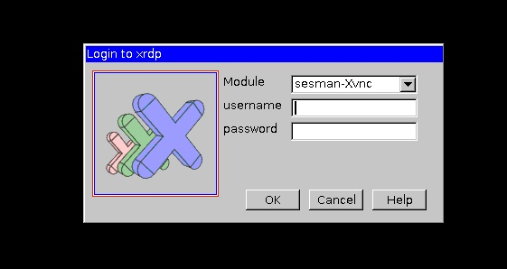

Figure 8

Introduce to XRDP

“Xrdp uses the remote desktop protocol to present a GUI to the users. The goal of this project is to provide a fully functional Linux terminal server, capable of accepting connections from rdesktop, freerdp, and Microsoft's own terminal server / remote desktop clients.” (Xrdp.org, 2017)

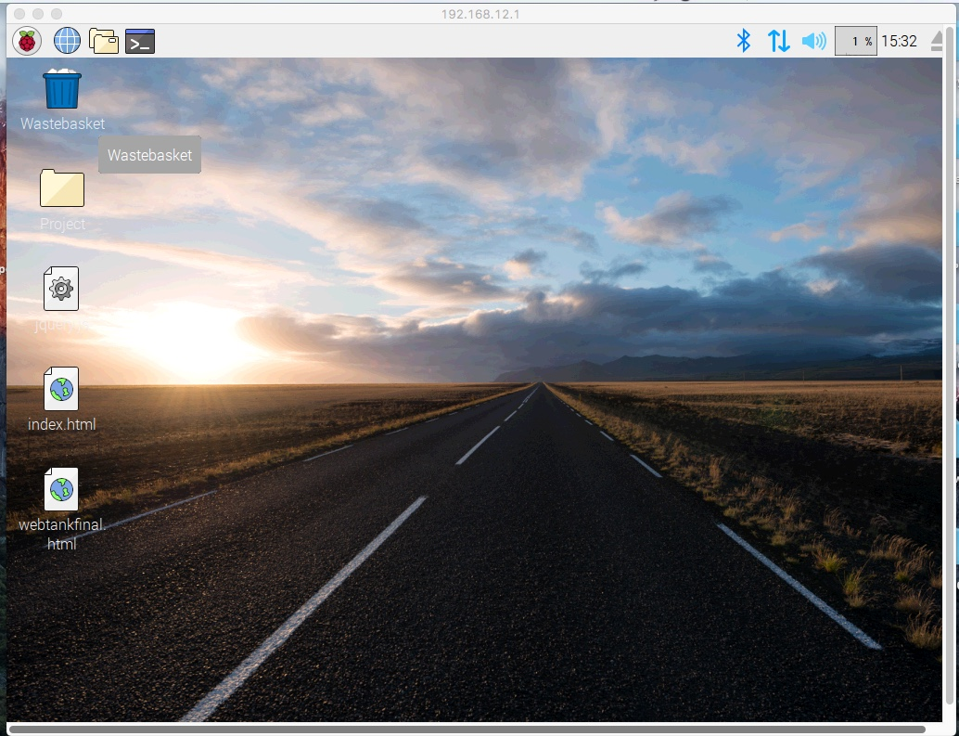

Figure 9

Support software • vnc4server

Use apt-get in raspberry pi command windows.Tap the raspberry IP address in computer remote desktop software then use default user name pi and password Raspberry then raspberry pi interface will show in the computer screen.

Thus when use raspberry pi programming screen keyboard and mouse is no longer need.

**4.5.3 remove original control unit by raspberry pi**

Figure 10 is the original control unit inside the tank, samplely cut all the wires and replace by raspberry pi and Motor drivers. But the power main control switch between Rx18 and 7.2 volt battery no removed. That switch will still control power supply between motor driver and battery.

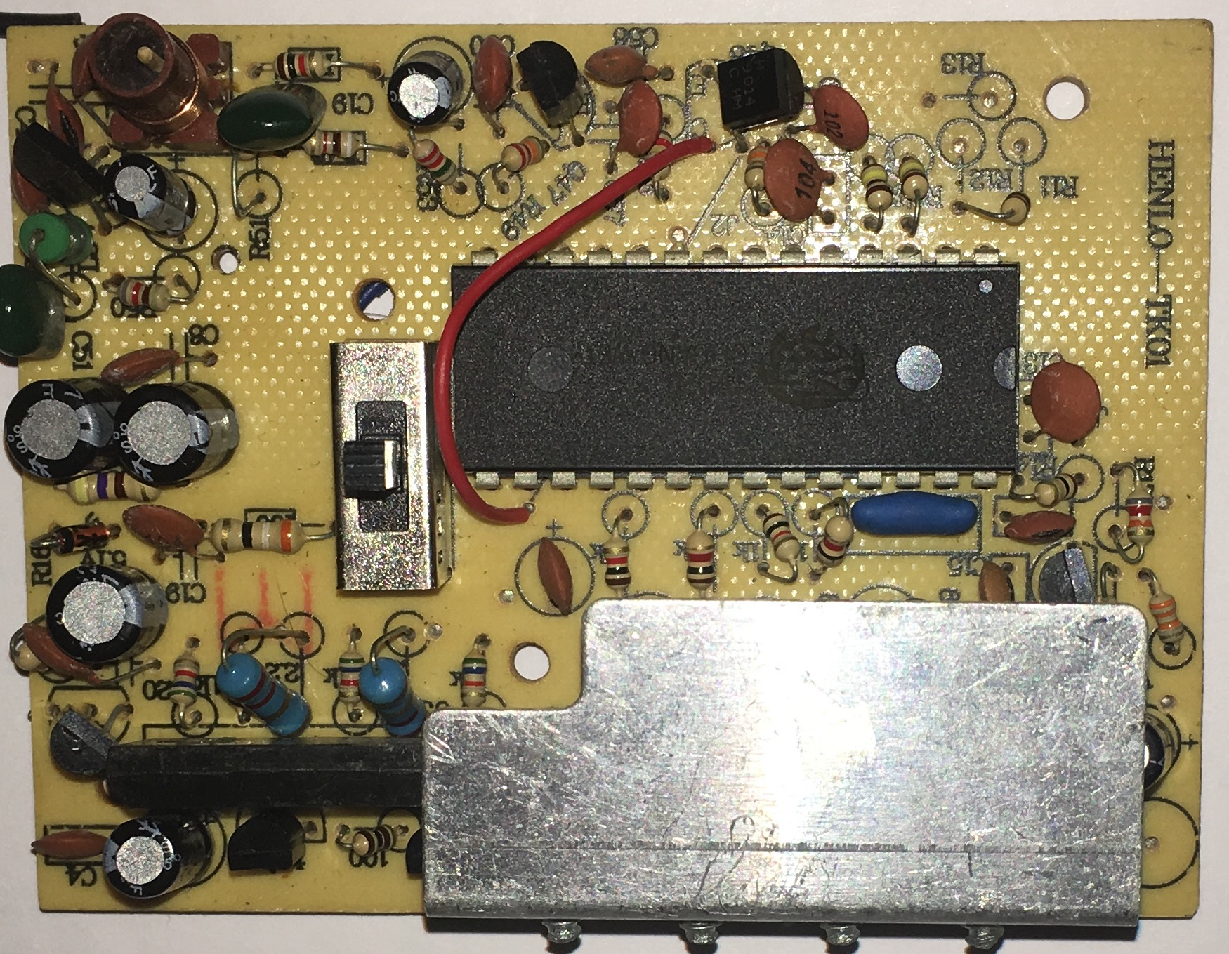

Figure 10

**4.6 Raspberry pi GPIO and python GPIO coding**

**4.6.1 GPIO used**

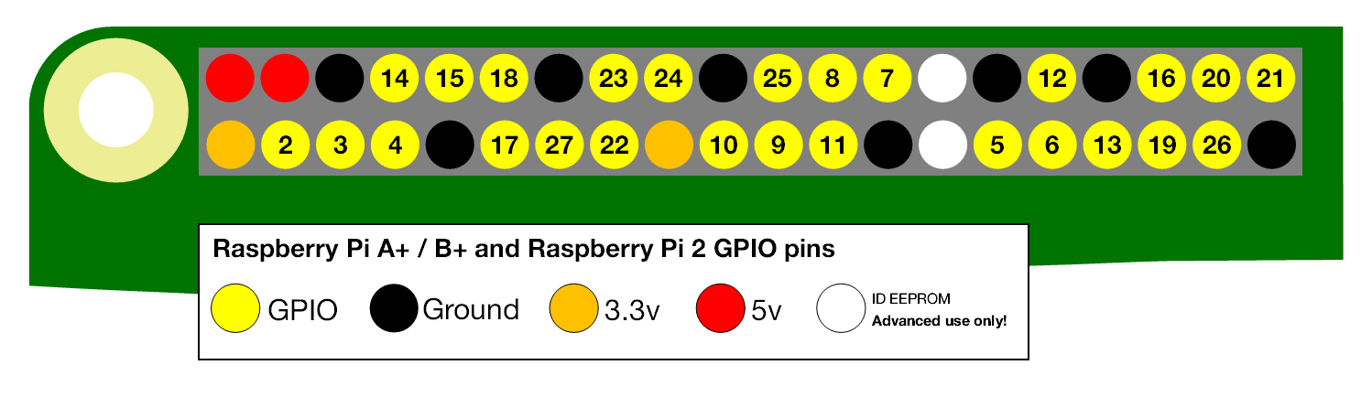

GPIO( 5 6 14 15 17 18 27 22 23 24 21) have been used, which is physical pin (11 12 13 15 16 18 21 22 29 31 40) in the board.

Figure 11 GPIO map

|  |  |
| --- | --- |
| **Physical GPIO pin** | **Connect with** |
| GPIO [11,12] [13,15] | Low level Motor driver to control caterpillars. |
| GPIO [16,18] [21,22] | Top level Motors Turret move and Gun up or down . |
| GPIO [29,31] | Shooting unit. |
| GPIO [40] | Laser unit for aiming. |

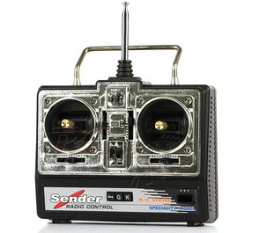

Figure 12 Remote controllor

**4.6.2 Original tank remote control actions**

Figure 12 is original remote controller for the tank, and it should replace by laptop or other users device. There are two joystick used in this controller which controlled 14 kinds of actions of the tank. All 14 kind of actions have show blew.

|  |  |  |  |  |  |  |
| --- | --- | --- | --- | --- | --- | --- |
| **Right joystick** | | |  | **Left joystick** | | |
|  | Shoot |  | Forward-R | Forward | Forward-L |
| Turret right | Stop | Turret left | Right | Stop | Left |
|  | Gun position |  | Backward-R | Backward | Backward-L |

**4.6.3 GPIO control code based on python**

According to L298N state table.

For low level two DC motors with nine actions witch control by left joystick in original remote controller. Tank use different speed of caterpillars in each side to turn right or left.

|  |  |  |  |  |  |  |
| --- | --- | --- | --- | --- | --- | --- |
| Actions | Left-Motor | | | Right-Motor | | |
| State | IN1 | IN2 | State | IN3 | IN4 |
| Stop | Stop | Low | Low | Stop | Low | Low |
| Forward | Forward | High | Low | Forward | High | Low |
| Backward | Backward | Low | High | Backward | Low | High |
| Left | Backward | Low | High | Forward | High | Low |
| Right | Forward | High | Low | Backward | Low | High |
| Forward-left | Stop | Low | Low | Forward | High | Low |
| Forward-right | Forward | High | Low | Stop | Low | Low |
| Backward-left | Stop | Low | Low | Backward | Low | High |
| Backward-right | Backward | Low | High | Stop | Low | Low |

def reset():

GPIO.output(11, GPIO.LOW)

GPIO.output(12, GPIO.LOW)

GPIO.setup(13, GPIO.OUT)

GPIO.setup(15, GPIO.OUT)

def left_forward():

GPIO.output(11, GPIO.HIGH)

GPIO.output(12, GPIO.LOW)

•

•

•

def right_back():

GPIO.output(13, GPIO.LOW)

GPIO.output(15, GPIO.HIGH)

•

•

•

def right_turn():

reset()

left_forward()

right_back()

time.sleep(0.2)

reset()

•

•

•

As this table above the entire tank actions is combine by left-motor and right-motor actions.

Set up all the GPIO port used as mode out.

This code in the right side is just an example. To show the def function, which widely used in my python GPIO code.

When run this code tap right_turn(): in the command windows, then left_forward() and right_back() function will triggered and keep this GPIO settings for 0.2 second then all the GPIO values will reset to low.

#!/usr/bin/python2

import RPi.GPIO as GPIO

import time

def init():

GPIO.setmode(GPIO.BOARD)

GPIO.setup(11, GPIO.OUT)

GPIO.setup(12, GPIO.OUT)

GPIO.setup(13, GPIO.OUT)

*GPIO.setup(15, GPIO.OUT)*

The complete pythonGPIO tank.py inside appendix of code.

**4.7 Access point and static IP**

**4.7.1 Access point**

Use “ifconfig” in raspberry command windows find the wlan0, which is the raspberry pi built-in Wi-Fi interfaces.

Software create_ap is open source software on GitHub which is used create an AP on raspberry. Cause raspberry pi is mainframe in this LAN, thus it also provides an static IP address (192.168.12.1).

**4.7.2 Create_ap**

Support materials

* hostapd
* iproute2
* iw
* iwconfig
* Dnsmasq
* iptables

“Hostapd is a user state for the AP and the authentication server daemon.It implements IEEE 802.11-related access management, will manage network generation by a daemon, allow to configure the SSID.” (En.wikipedia.org, 2017)

DNSmasq is a compact and easy tool for configuring DNS and DHCP for small networks that provides DNS functionality and optional DHCP functionality. It serves those domain names that are only applicable locally, and these domain names are not present in the global DNS server. And allows the DHCP assigned address to be properly resolved in DNS.

Installation

1 git clone <https://github.com/oblique/create_ap>

2 cd create_ap

3 make install

4 sudo apt-get install hostapd iproute2 iw iwconfig dnsmasq iptables

5 sudo create_ap –n wlan0 tank up793903

After this 5 step a AP named tank have create an AP with password up793903 (without internet sharing method). Now devices can join this LAN, which built by the raspberry pi.

**4.8 Webserver**

**4.8.1 Python webserver**

Python 2.7 will used to program the python webserver, what different between 3.5 is the BaseHTTPserver change to Http.server. Do_post, do_get and split statement is the main part of python server code.

The python webserver code can divide in to four logic part, import python GPIO code, split the URL data out, define the value in data make actions, server on the chosen port.

|  |  |
| --- | --- |
|  | Main statements explain |
| Head file | From BaseHTTPserver import HTTPServer, BaseHTTPRequestHandler • BaseHTTPserver: Provides basic Web services and processor classes. The BaseHTTPRequestHandler is processed when the HTTP request arrives, but it can not itself be made to the request, and each request method is handled by another derived class. |
| Import urllib • Python urllib module used to deal with url-related operations. |
| Import tank • Import tank.py GPIO setting code. |
| UTF-8 • UTF-8 is an coding set, widely used in programming. |
| From abc import ABCmeta, abstractmethod. • Define an abstract class that can enforce a common method of a subclass |
| Split URL | do_get : GET request data will be attached to the URL, mark ‘?’ divide the URL and transfer data, the parameters are connected with & ,if the data is alphabetical / number sent it intact. if it is a space converted to +. If it is Chinese / other characters, the string is directly encoded with BASE64; |
| Split: python split statement self.path.split(‘split mark’, X) • self.path.split: split the path (url) • split mark to split data use ‘?’ • X: number of divisions. |
| urllib.unquote: Decode the url |
| URL request | Self.protocal_version= “ HTTP/1.1” • set http protocal |
| Self.send_response( 200 ) • response normally |
| Self.send_header(“content-type”, “ application/json; charset=UTF-8”) • Use coding set UTF-8 and json data type. |
| Self.end_headers() •end header |
| Self.wfile.write() • end request |
| Actions | If statement judge what value received. |
| Server on port | serverAddress = ("localhost", PORT_NUM) server = HTTPServer(serverAddress, DispatcherHandler) server.serve_forever() • localhost: raspberry pi IP address. •server.serve_forever(): Loop forever and wait for stop. |

**4.8.2 Python webserver code**

*Assume data is 1.*

|  |  |  |  |  |
| --- | --- | --- | --- | --- |
| http:// | 192.168.12.1 | :8899 | /car? | a=1 |
|  | Raspberry pi IP address | Port | Split mark ‘?’ | data |

|  |  |
| --- | --- |
|  | Split url |
| 1  2  3  4  5 | Class DispatcherHandler(BaseHTTPRequestHandler):  def do_GET(self):  data= self.path.split('?', 1)  action = data[0]  numdata = {}  if len(data) == 2:  data_value = data[1]  value = data_value.split('=')  if len(value) == 2:  numdata[value[0]] = urllib.unquote(value[1]) |
| 6 |
| 7  8  9  10 |
|  | • Line1: class baseHTTPRequesthandler  • Line2: use get method  • Line3: after split data is{‘/car’, ‘a=1’}  • Line4: action=data[0] means action= ‘/car’.  • Line5: process numdata  • Line6: len() python statement show the length of the character string.  • Line7: data_value= data[1]. Means data_value is “a=1”.  • Line8: split data_value use mark ‘=’ after split is {‘a’, ‘1’}.  • Line9: define the length of data_value  • Line10: value={‘a’,’1’}; value[0]=a; numdata[a]=1, means built {‘a’: ‘1’} |

With every time URL received this code will cut the data out and recombine a new dictionary data type {‘a’: ‘X’}.Jaon in python (X is variable url data).

|  |  |
| --- | --- |
|  | Response form server |
| 1  2  3  4  5  6  7  8  9  10  11 | TK=TankAction ()  RT= {}  if self.path.startswith("/car?"): RT["return"] =TK.action(numdata)  else:  RT ["return"] = -1  self.protocal_version = "HTTP/1.1" self.send_response(200) // response normally.  self.send_header("Content-type", "application/json; charset=UTF-8") self.end_headers()  self.wfile.write(RT) |
|  |
|  | • Line 2 :judgment url data start with /car?. That is the right url data.  • Line 3 :trigger subclass RunCar (TK=RunCar).  • Line 4 :numdata=’0’ means one action finish {‘return’: 0}  • Line 6 : HTTP protocol  • Line 7 : send RT(return=0) or (return=-1)to browser.{“return”:0} or {“return”:-1}  If don’t send header back that means no response from server the URL will continue request from browser trigger three times in one click. |

|  |  |
| --- | --- |
|  | Parent class of class Runcar |
| 1  2  3  4  5 | class usercommand ():  __metaclass__ = ABCMeta  @abstractmethod  def action(self,numdata):  pass |
|  | •Line 2, 3: create an abstract class like c language.  •Line 4: the subclass will inherit the def action(self, numdata). Repackage /car and { “a”: x} send this to subclass. |

|  |  |
| --- | --- |
|  | Actions |
| 1  2  3  4  5  6  7  8  9  10  11  12  13  14  15  16  17 | class TankAction(usercommand):  def __init__(self):  tank.init()  def action(self,numdata):  act = int(numdata ['a'])  if act == 0:  tank.stop()  return 0  if act == 1:  tank.forward()  return 0  if act == 2:  tank.back()  return 0  else:  return -1 |
|  | • Line 1: class RunCar  • Line 2: constructor when first time built this class will use.  • Line 3: Use init() in python GPIO setting code.Inside Tank.py.  • Line 9 : act=1 car.forward.  • Line 13: when else return ‘-1’, if no return here it will return none anyway. |

In class runcar will define received data then driver the GPIO python code.

Next step is make the web server listen on the chosen port.

|  |  |
| --- | --- |
|  | Listen on port |
| 1  2  3  4  5 | if __name__ == "__main__":  PORT_NUM = 8899  serverAddress = ("", PORT_NUM)  server = HTTPServer(serverAddress, DispatcherHandler)  server.serve_forever() |
|  | • Line2: port number default port number is “8080”.  • Line3: “” will start server on local host. |

From webserver the variable data in URL can be detective and trigger actions. Thus the website design ideal is link variable URL to buttons.

|  |  |  |
| --- | --- | --- |
| Actions | URL | |
| Link | Json type Data |
| Forward | 192.168.12.1:8899/car?a=1 | {‘a’: ‘1’} |
| Stop | 192.168.12.1:8899/car?a=0 | {‘a’: ‘0’} |
| Backward | 192.168.12.1:8899/car?a=2 | {‘a’: ‘2’} |
| Left-turn | 192.168.12.1:8899/car?a=3 | {‘a’: ‘3’} |
| Right-turn | 192.168.12.1:8899/car?a=4 | {‘a’: ‘4’} |

For total 16 actions data used ( 0 to 15) integer value.

**4.8.3 Complete code**

The complete code name tankwebserver.py in the appendix of code.

**4.9 Controller website**

**4.9.1 LAMP**

For user device connect to the controller website the raspberry pi need built an website on raspberry pi IP address, The LAMP software frame is used to make raspberry pi became an LAN host server.

Support materials

• Apaches

• Mysql-server

• Php5

• Php5-mysql

After install all reboot raspberry pi the internet server start on local host (192.168.12.1).

Use tank controller html file replace the default index.html *( /var/www/html/index.html)*

**4.9.2 Local resource**

The tank controller website is running in the LAN all the online resource can’t be load, thus jquery.js must be download use locally. Just put jquery.js into same location as the controller html( /var/www/html).

**4.9.3 html file**

**4.9.3.1 Headers**

• Built-in CSS

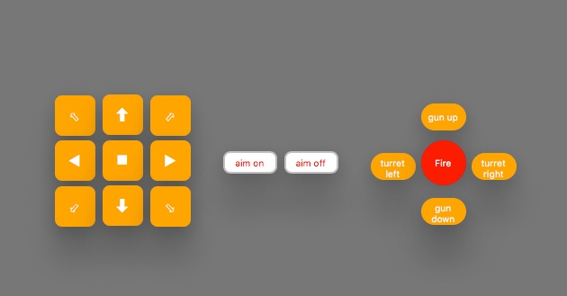

Figure 13

|  |  |
| --- | --- |
| Class | Settings |
| Body | Background colour |
| Low-level | Left unit button |
| Mid | Aim on/off |
| Top-level | Right unit button |
| Fire | Shoot button |

Figure 13 is all the buttons use CSS file

• jQuery and ajax

|  |  |
| --- | --- |
|  | **<head>** |
| **1**  **2**  **3**  **4**  **5**  **6**  **7**  **8**  **9**  **10**  **11**  **12** | $(document).ready(function(){  “ $("#forward").click(function(){  $.ajax({  type: "GET",  url: "http://192.168.12.1:8899/car",  data: {"a": 1},  dataType: "json",  cache: "false",  success: function(data){},  error: function(data){}  });  });” (Cnblogs.com, 2017) |
|  | **•** Line 1: Make sure all the document has been load then do jquery job.  • Line 2: jquery click function inside { }After action the implementation code.  • Line 5: webserver listening address.  • Line 6: The transmitted data. Means a=1; json data type |

Ajax (Asynchronous JavaScript and XML) it has the ability send data in background without reload the whole page.

All 15 actions used same code just change the data.

**4.9.3.2 body**

In html body use various div to describe buttons locations.

**4.9.3.4 All html code**

The whole html file webcontroller.html in appendix of code.

**4.10 Extension**

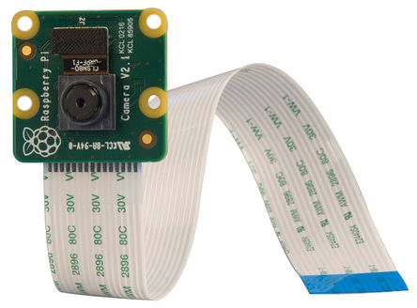

Figure 14

**4.10.1 Video stream**

**4.10.1.1 Picam**

Figure 14 is an Picam use PCB connect to raspberry pi. The extension involves sending the video stream captured by Picam to the website.

**4.10.1.2 MGPG-streamer**

Support Martials

• libjpeg8-dev

• Cmake

Install MGPG-streamer through “sudo apt-get install” Change the video stream basic settings through nano editor in file input_raspicam.c.

|  |  |
| --- | --- |
| Function | Settings |
| Fps | 35 |
| Width | 320 |
| Height | 240 |

Setting 35 frames per second and 320x240 video stream output.

If the FPS setting too high will stuck video stream.

For easy start an sh file have been used

|  |  |
| --- | --- |
|  | Sudo nano Picam.sh |
| 1  2 | *cd mjpg-streamer-master/mjpg-streamer-experimental ./mjpg_streamer -i "./input_raspicam.so" -o "./output_http.so -w ./www"* |
|  | For start video stream just need tap *sh picam.sh* in raspberry pi command windows. |

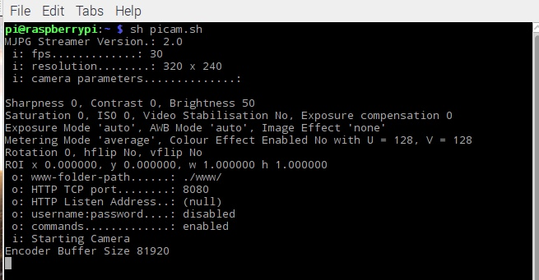

Figure 15

The video stream can be finding on MGPG-streamer main page (192.168.12.1:8080) severed on default port. And the MGPG offered a JavaScript link (192.168.12.1:8080/javascript_simple.html).

**4.10.1.3 Add Video streamer to controller website**

Iframe HTML label have been used to add the video stream website to the controller page.

|  |  |
| --- | --- |
|  | <div> |
| 1 | <iframe src=”<http://192.168.12.1:8080/javascript_simple.html>” frameborder="0" width="360" height="250" ></iframe> </div> |

Iframe support add a new page to website. Frameborder= “0” disable frameborder.

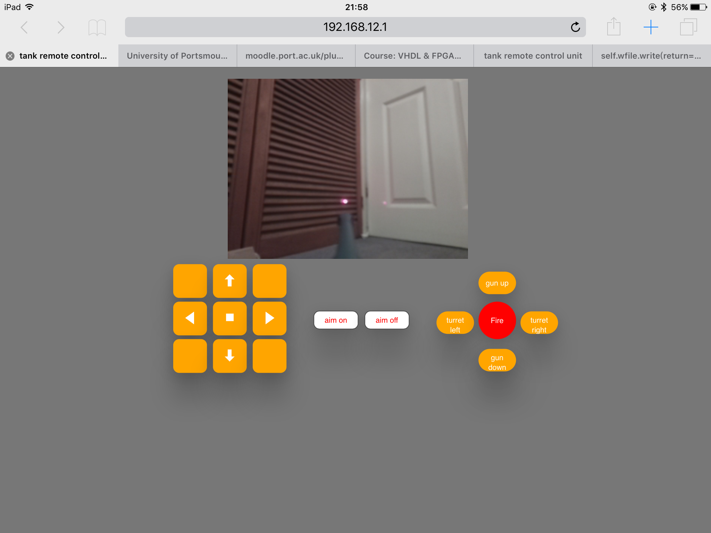

Add this code to web controller html, Reboot the raspberry pi, use the .sh start video stream, the video stream now show in the controller website.

**4.10.2 Laser light**

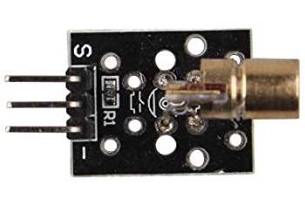

Figure 16

**4.10.2.1 5V Laser module**

Figure 16 is 5-volt laser module.

Replace the original LED light by 5V laser module. This module have three pins s will connect to raspberry pi GPIO 40 the rest will connect 5V and GND.

**4.10.2.2 Install Laser module and power on**

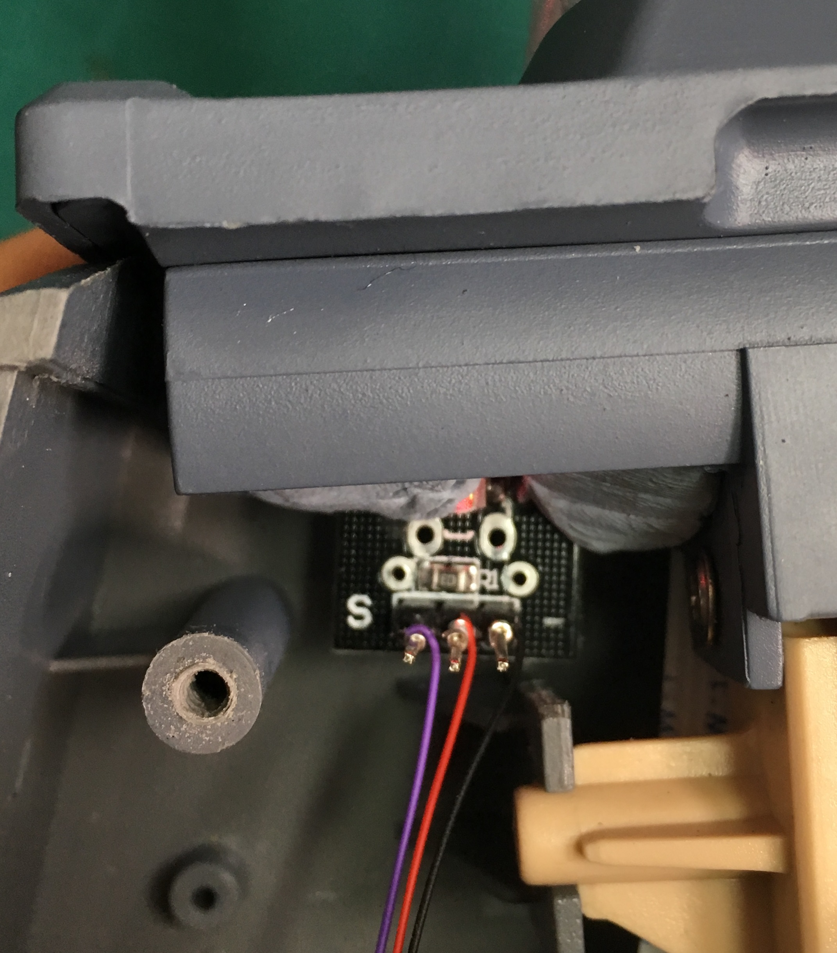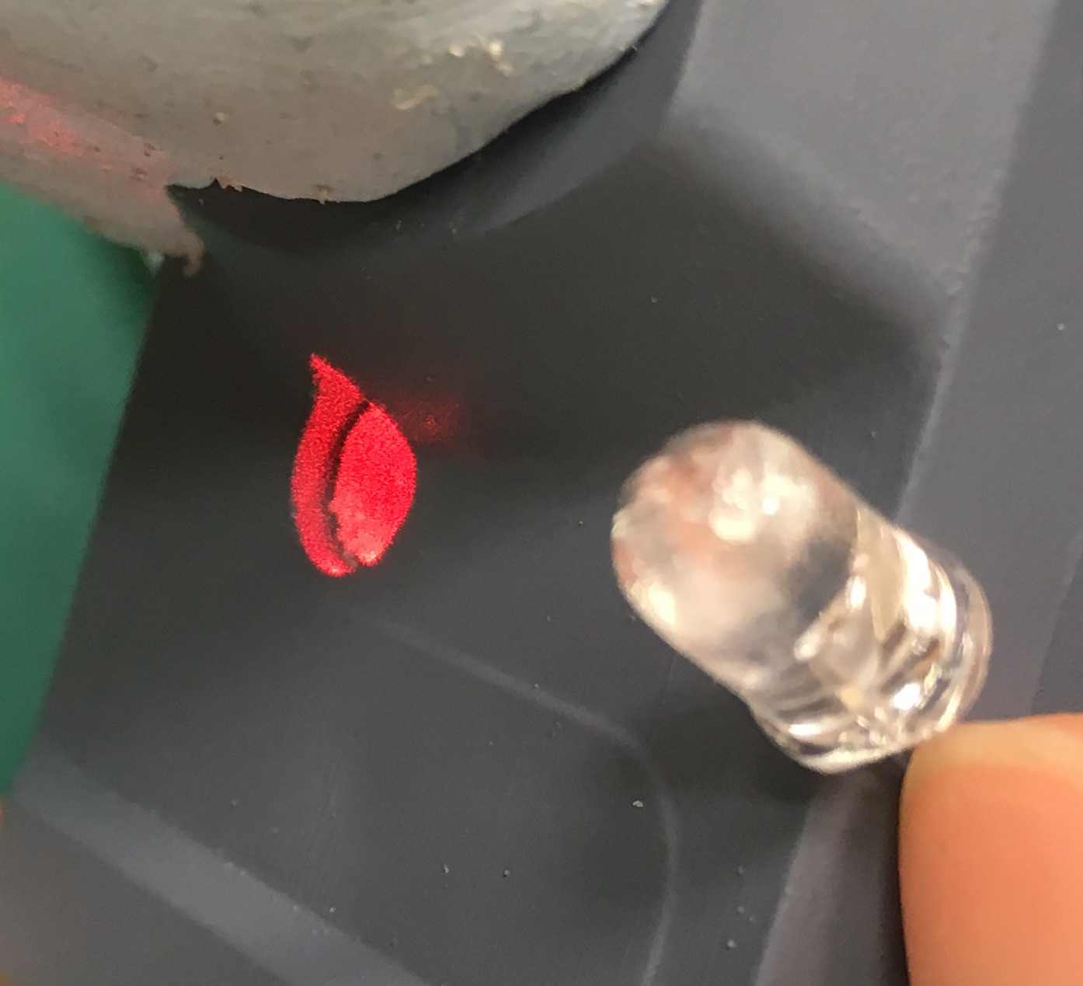

Figure 17 Figure 18

In figure 17, purple wire is connecting to raspberry pi GPIO 40; the red wire is 5-volt power; the black wire is GND.

In figure 18， is the original LED, which removed by laser module.

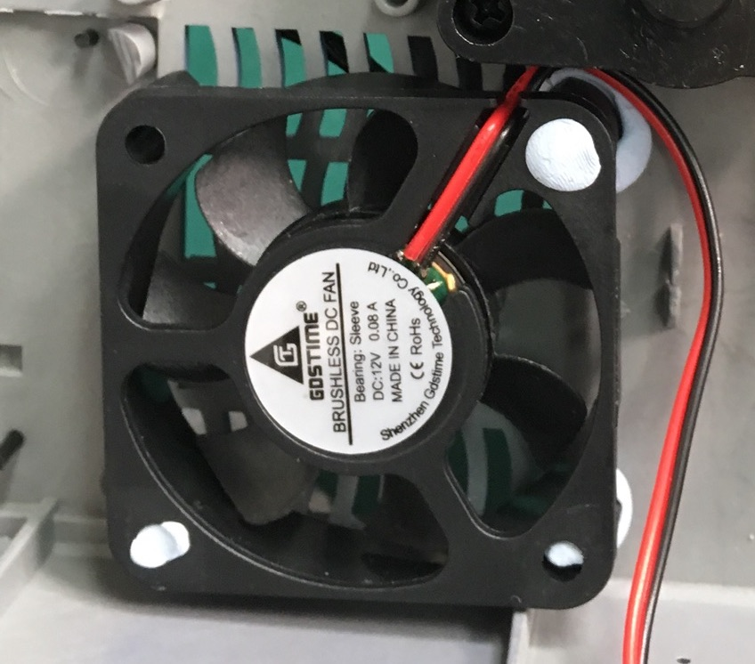

Figure 19

**4.10.2.3 Cooling Fan**

A cooling fan has added inside the tank above raspberry pi to decrease the temperature.

Figure 19 is an cooling fan connect to 7.3-volt power source.

**4.12 Soldering and wires**

The original 7 way flat cable between top level and low level still used solder it to male pin and connect to GPIO.

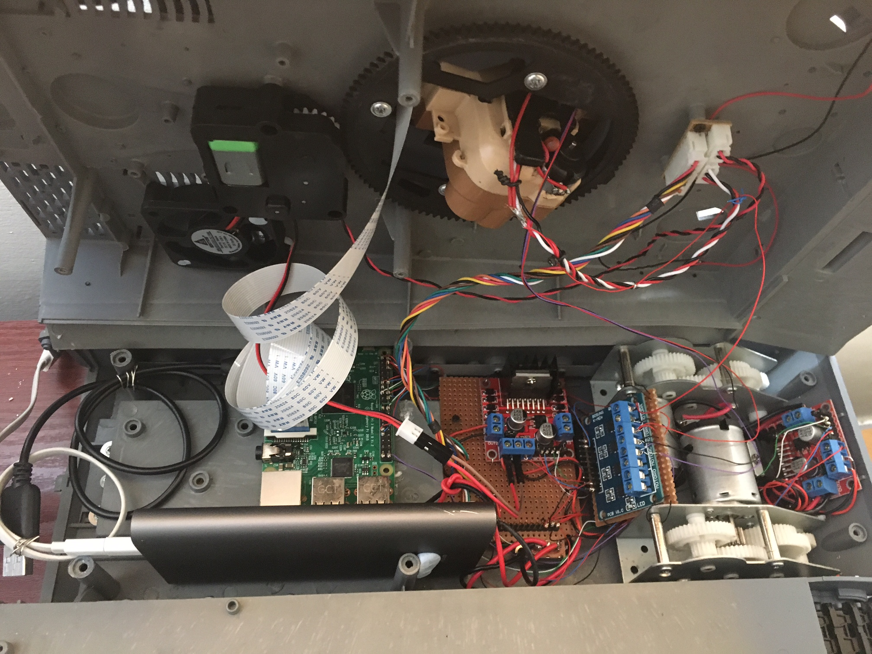

Figure 20

Figure 20 is a photo of raspberry pi and all the motor drivers and power supply circuit.

**5. Testing and Improvements**

**5.1 Main Function test**

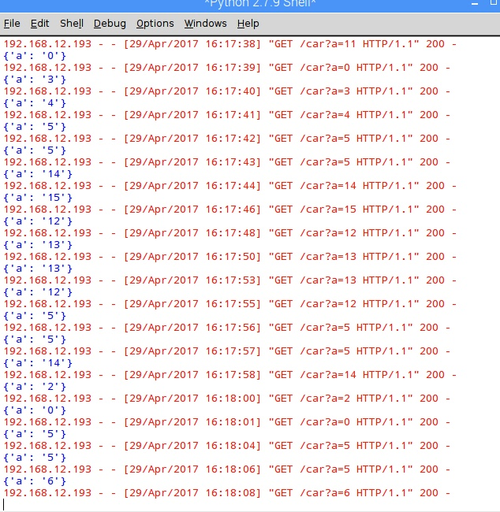

Figure 21

Figure 21 is a screen shot of python webserver command windows( python 2.7.9), show webserver actions when controller website buttons clicked.

Use “gpio readall” in raspberry pi command window, the changing of GPIO can be found.

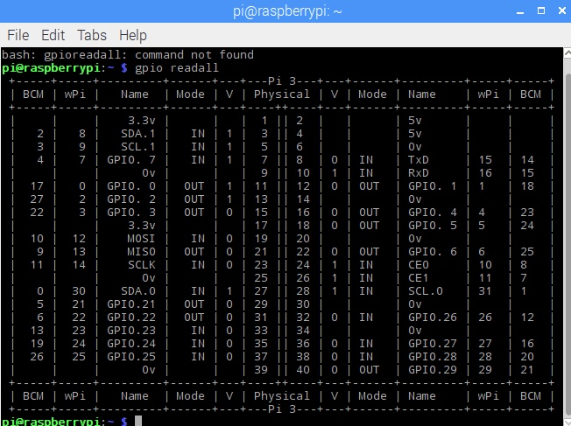

Figure 22

Figure 22 is raspberry pi GPIO table all the use GPIO pin is mode out. And this photo is show the action forward as physical pin 11(“1”); 12(“0”).

**5.2 Hardware**

**5.2.1 Chassis**

|  |  |
| --- | --- |
| Functions | Click action |
| Forward | Once triggered Forward until stop triggered or any low level action triggered. |
| Stop | Any low level actions stop |
| Backward | Like action forward, keep going until other button taped. |
| Left-turn | Right side motor forward keep 0.3 second.  Left side motor backward keep 0.3 second. |
| Right-turn | Left side motor forward keep 0.3 second.  Right side motor backward keep 0.3 second. |
| Front-left | Right side motor keep forward, left side motor stop. |
| Front-right | Left side motor keep forward, right side motor stop. |
| Back-left | Right side motor keep backward, left side motor stop. |
| Back-right | Left side motor keep backward, right side motor stop. |

There seems have a problem in left side motor, compare with right side motor it have a start delay less about 0.1 second. But when trigger right-turn will stop for little bit time.

**5.2.2 Turret**

|  |  |
| --- | --- |
| Functions | Click action |
| Turret-left-turn | Turret-left keep 0.2 second. |
| Turret-stop |
| Turret-right-turn | Turret-right keep 0.2 second. |
| Turret-stop |
| Gun-up | Gun-up keep 0.7 second |
| Gun-lock |
| Gun-down | Gun-down keep 0.7 second |
| Gun-lock |

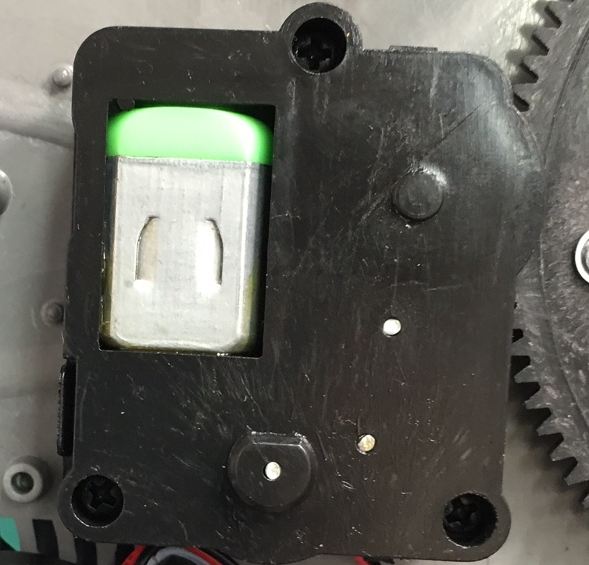

Figure 23

Figure 23 is the turret turn unit.

Turret-right the turret turn unit DC motor forward, Turret-left the motor backward.

Gun up/down unit also control by an DC motor in the original controller left joystick down control both gun up/down. Because the gun position unit is driver by an cylinder (Figure 24)when the cylinder clockwise turn the gun will go up and down over and over. That means the original DC motor only can go clockwise.

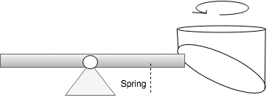

Figure 24

But in controller website achieved to function gun up and down. For this objective the wires connection in gun position unit have changed.

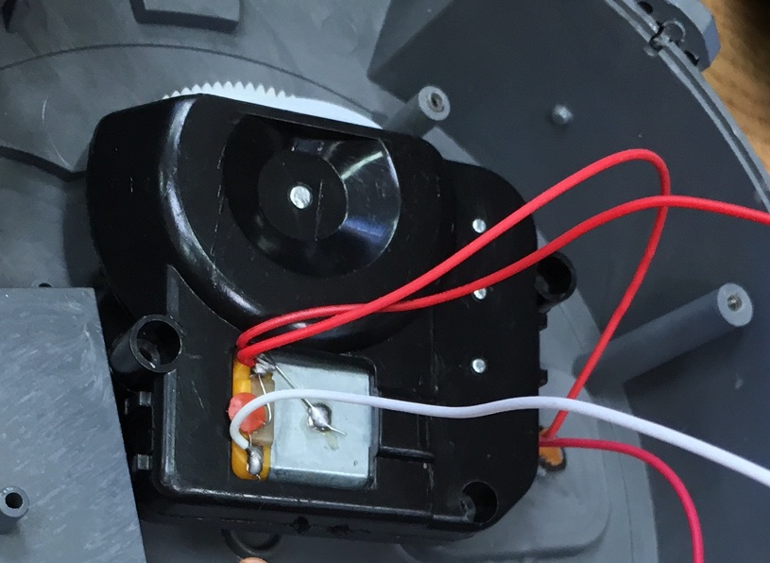

Figure 25

Figure 25 is a photo of gun position unit, as the original controller table gun position and shoot share two IO pin in the original board.

What change have made is separate this two unit sharing cable connect to motor driver and assign GPIO.

**5.2.3 BB GUN**

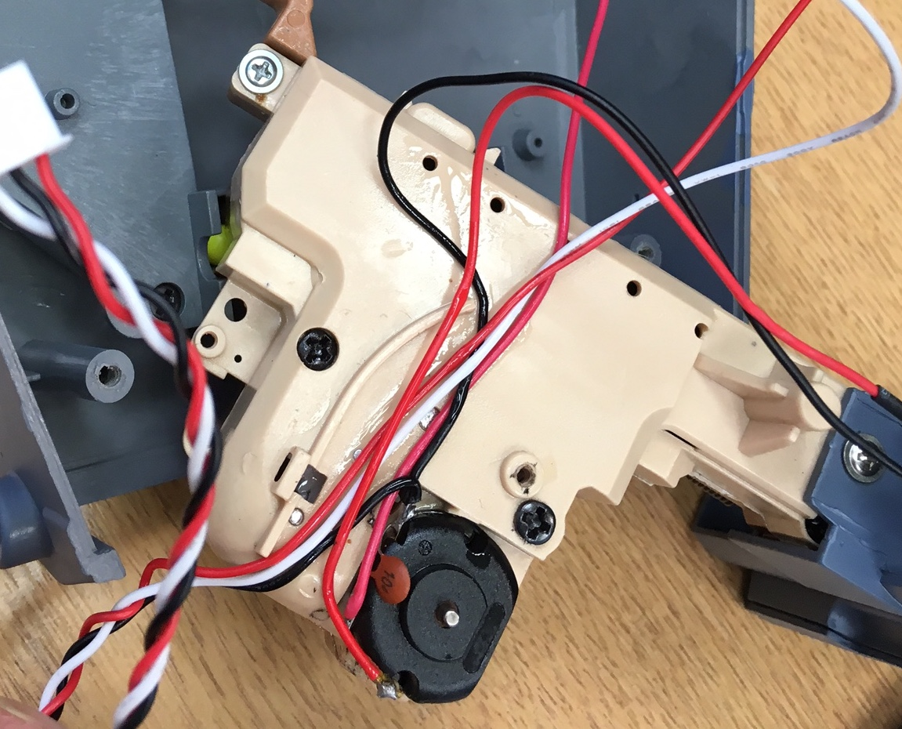

Figure 26

The toy tank uses an electric BB gun (figure 26) to shoot BB bullet.

The theory of this unit is when motor go backward the wheel will pull the spring when the spring going to maximum length it will automatic release spring then bullet shoot.

Thus should given motor enough time to pull the spring.

**5.2.4 BB Gun and laser**

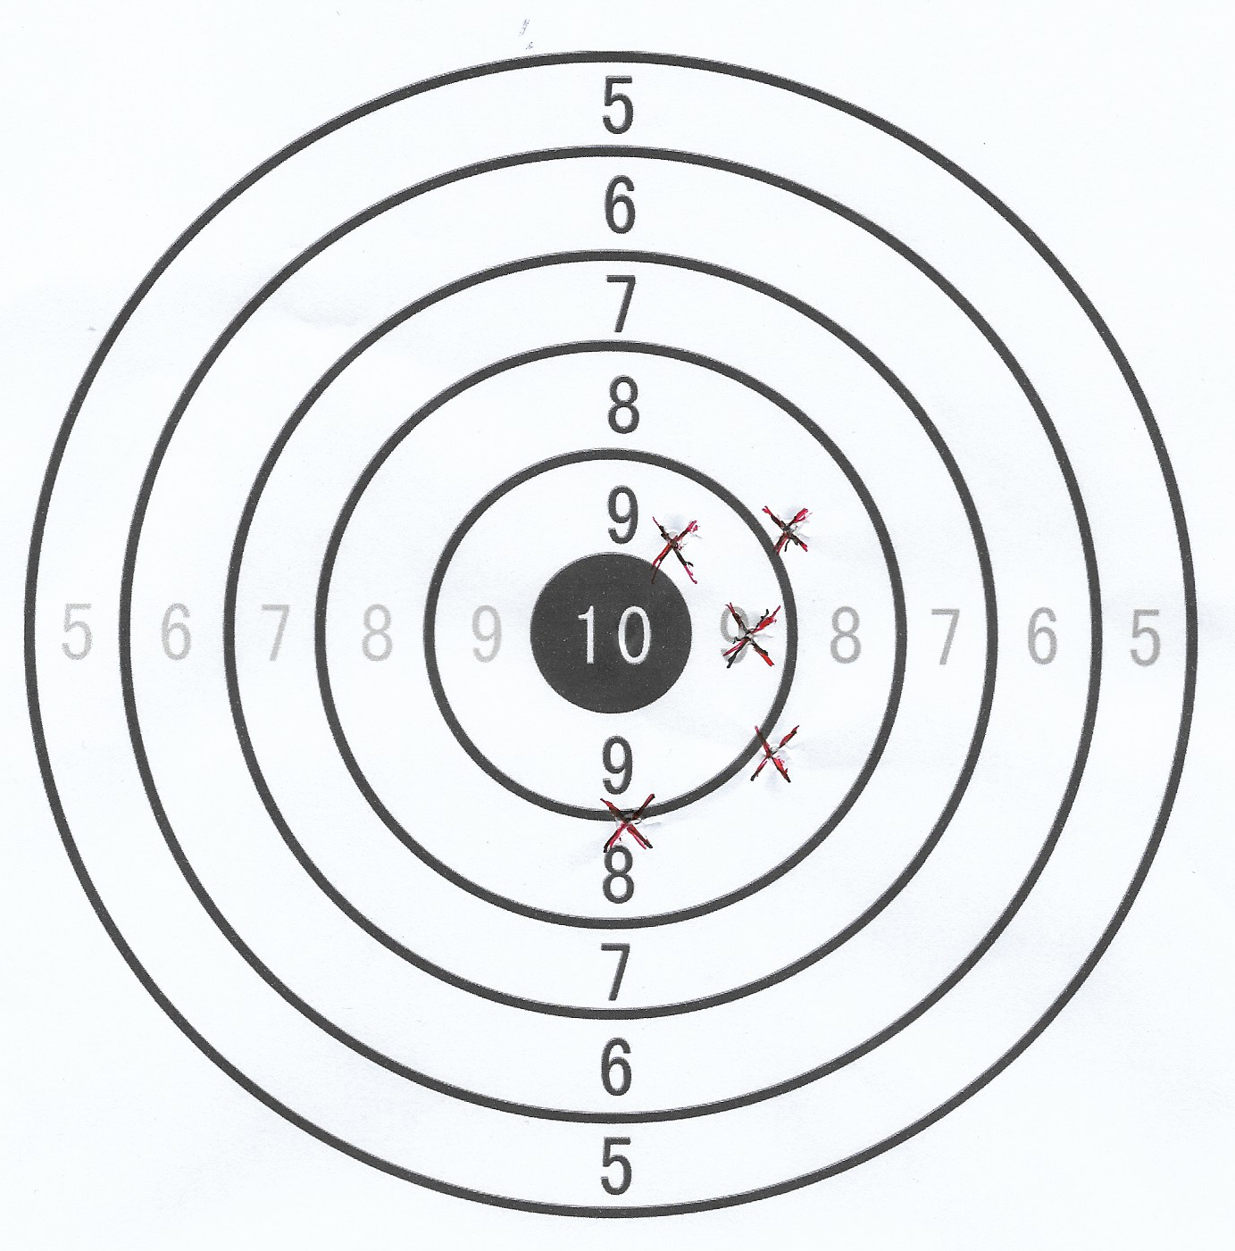

Figure 27

The design idea for laser unit is when play use video stream paly the tank there need a marker to show where bullet will go. Laser unit is a perfect option after same adjustment. Figure 27 is a target map after 5 times shooting with distance 1.5 meter.

**5.2.5 Hardware summary**

After testing, all the 15 actions works.

**5.3 Video stream and remote control testing**

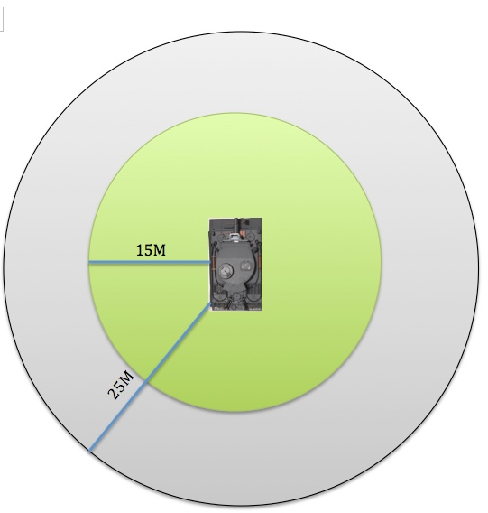

Figure 28

The maximum distance of stable video stream is about 15 meter. The maximum remote control distance is 25 meter. Test on the ground, if used inside a building may affect this performance. The remote control performance is limited by raspberry pi built Wi-Fi module, a more powerful Wi-Fi module

will improve the control distance.

**5.3 Software improvement**

**5.3.1 Software Boot automatically starts**

Every time before start raspberry pi need to start create_ap and run python webserver. Boot automatically start this software will make remote control tank start more easily and quickly.

**5.3.2 Rc.local**

Use nano editor edit /etc/rc.local add start command into this file before exit 0;

|  |  |
| --- | --- |
| Create-ap | Sudo create-ap –n wlan0 tank up793903& |
| webserver | Python /pi/etc/webcontrol/tankwebserver.py& |
| Video stream | Sudo sh /pi/etc/picam.sh& |

‘&’ Used to avoid software can’t built stuck whole system.

**5.4 Website**

The controller website only define the click function that means one tap on button will trigger one action. Maybe the buttons used in website change to joystick will improve users experience and more easy to control. But seems no time for that.

**6. Conclusion**

**6.1 Project conclusion**

In this project raspberry pi is the core part with python programming achieved a basic webserver and control GPIO output. Create-ap and LAMP software have been used built raspberry pi as an access point also LAN host publish the tank controller website. Through three motor drivers control totally 15 kinds of actions of the tank. MJPG-stream software used to offer a website with video stream.

**6.2Aims achieve**

Obviously all the original actions of this toy tank is control by the website and raspberry pi, and there are 3 more actions( gun up, aim on/off)have add in the toy tank.

Also a Picam provide with video stream.

**6.3 Future work**

For the future work should develop a mobile app to replace the control website. And more automatic functions should be the main aim, add various sensor achieve auto driver function or auto lock target then shoot BB bullet.

**6.4 Technical learning**

Through this individual project raspberry pi have deeply used to develop verity functions, raspberry pi provide an friendly easy operator Linux system and also given developers ultimate possible, inspire and change people’s ideal. Python language used as main programming language, python with raspberry pi can solve a lot of questions and that knowledge will still very useful in future career. Also learn HTML file and various Internet protocols, this is the first time I understand how the website work.

**6.5 Outcome of the unit**

Through this unit student need to design built and test make all ideal came true. Not only the knowledge student self-studies, but also most important thing is the ability achieved. To be frankly this is the first experience for most students to finish one challenge project by themselves.

**References**

En.wikipedia.org. (2017). *Internet of things*. [online] Available at: https://en.wikipedia.org/wiki/Internet_of_things [Accessed 1 May 2017].

En.wikipedia.org. (2017). *Telerobotics*. [online] Available at: https://en.wikipedia.org/wiki/Telerobotics [Accessed 1 May 2017].

En.wikipedia.org. (2017). *Web server*. [online] Available at: https://en.wikipedia.org/wiki/Web_server [Accessed 1 May 2017].

En.wikipedia.org. (2017). *LAMP (software bundle)*. [online] Available at: https://en.wikipedia.org/wiki/LAMP_(software_bundle) [Accessed 1 May 2017].

W3schools.com. (2017). *Introduction to HTML*. [online] Available at: https://www.w3schools.com/html/html_intro.asp [Accessed 1 May 2017].

En.wikipedia.org. (2017). *JavaScript*. [online] Available at: https://en.wikipedia.org/wiki/JavaScript [Accessed 1 May 2017].

Xrdp.org. (2017). *xrdp*. [online] Available at: http://www.xrdp.org [Accessed 1 May 2017].

Cnblogs.com. (2017). *Ajax Asynchronous request - 123 - cnblogs*. [online] Available at: http://www.cnblogs.com/AndroidJotting/p/6256093.html [Accessed 20 Mar. 2017].

**Bibliography**

Hetland, M. (2010). *Beginning Python*. 2nd ed.

Spivak, R. (2017). *Let’s Build A Web Server. Part 1.*. [online] Ruslan's Blog. Available at: https://ruslanspivak.com/lsbaws-part1/ [Accessed 20 Mar. 2017].

Docs.python.org. (2017). *20.19. SimpleHTTPServer — Simple HTTP request handler — Python 2.7.13 documentation*. [online] Available at: https://docs.python.org/2/library/simplehttpserver.html#module-SimpleHTTPServer [Accessed 20 Mar. 2017].

Triajianto, J. (2017). *Simple HTTP Server and Client in Python*. [online] Junian.Net. Available at: https://www.junian.net/2014/07/simple-http-server-and-client-in-python.html [Accessed 8 Apr. 2017].

Robotics / Electronics / Physical Computing. (2017). *Tiger 1 BB airsoft RC Tank – V3*. [online] Available at: https://trandi.wordpress.com/2011/05/14/tiger-1-bb-airsoft-rc-tank-–-v3/ [Accessed 1 Mar. 2017].

W3schools.com. (2017). *W3Schools Online Web Tutorials*. [online] Available at: https://www.w3schools.com/ [Accessed 30 Mar. 2017].

**Appendix A- Preliminary work**

**Background Theory and Research**

In “rctanksaustralia.com” there are a lot of useful information about tiger 1. And I find out two successful project based on RC tank one have chosen to replace all the electronics inside the tank and use Arduino devices with motor control drive the motor, another one hijack RF receiver board singles which send to the main control unit and use the Raspberry pi pretend to be the RF receiver.

After research, there are four places in this toy tank seem possible to connect the GPIO of the Raspberry Pi.

* Between the remote control and the RF receiver

To do this, it would be necessary to decode the output signal from remote control and use raspberry to receive and analyze it.

* Between the RF receiver and the microcontroller

Inside the HengLong tank the RF receiver processes and the microcontroller is in one chip. If find out which part is the RF receiver’s

Output pin and decode that then connect GPIO here.

* TK-028 center processer

This is a 28-pin processer if all the input can be fund then connect the GPIO the tank will be work. But if that way is possible all the type of movement signals must be record.

* Between the microcontroller and the five motors

These are five DC motors, use GPIO connect to relay to control all of them. That design will be sample but may be the space will be not enough.

**What done so far**

Henglong tank tiger 1 has been bought from amazon.com, raspberry pi from cpc.com. Trying my first python program “Hollow world”, also the GPIO program to turn on an LED.

In the hardware side the signal from remote control has been recorded.

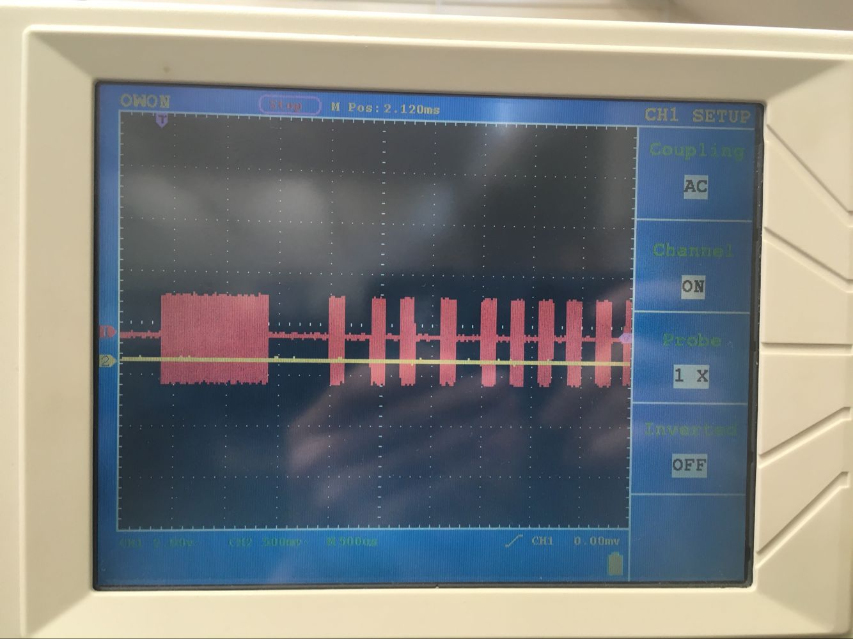

(Forward)

**Appendix of code**

**All the code by my own code and support code can be found in this Link ( include any quick start guide)**

https://drive.google.com/drive/folders/0B6A34P6Biz7neUNLRFpjUjdfc1U?usp=sharing

**Here is an hard copy for my code.**

**Appendix**

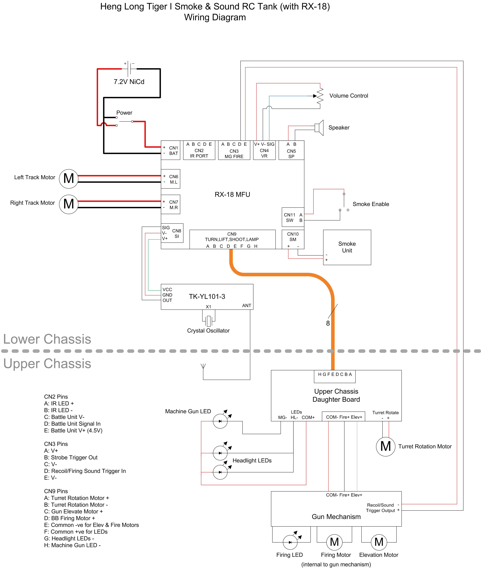

Figure 1 The original electric schema from tank made company website